Title
(The title of the article is no more than 12 words in English.
If there are more than 12 words, make it two part: title and subtitle)
Author name¹* and Author name²
¹Department, University, City, Country; ²Department, University, City, Country
e-mail for the *corresponding author
Abstract
Provide a self-contained and readable abstract (of up to 250 words) that briefly explains the salient aspects of the content, including, but not exclusively, the methods used to address the research question/hypothesis, a summary of the results, conclusions, applications or implications.
Key words: [provide 3-5 key words]

1. Heading 1 [use this style for level one headings]
[Type your text here]

1.1 Heading 2 [use this style for level two headings]
[Type your text here]

1.1.1 Heading 3 [use this style for level three headings]
[Type your text here]
Heading level 4. [Use this style for level four headings]. Run the text on after a punctuation mark.
It is best if authors use three-level headings.

Block quote
If the quotation is over 40 words, you need to make it a block separate from the main text. In this case, use this style to display your quote.
Tables and figures
If you present your data in a table, follow this sample:
Table 1. [name of the table]
Items | Content 1 | Content 2

The caption comes above the table, started with “Table 1. (title of the table of no more than 12 words)” in Times New Roman, 10 points, bold-faced,.
If you present your data in a figure, the figure must be saved as a .jpg or .png file before being inserted to the main text. The caption comes below the figure, started with “Figure 1. (title of the figure of no more than 12 words)” in Times New Roman, bold-faced, 10 points.
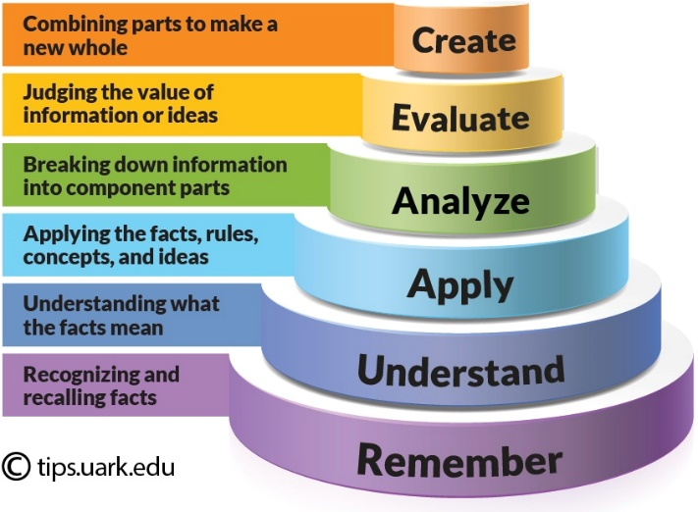
Figure 1: The Bloom's Taxonomy

If the table or the figure is taken from a source, reference the author (after the caption) or acknowledge the source (by adding the information about it).

References
Manuscripts must conform to the American Psychological Association (APA) style guidelines, 7th Edition (2010).

Information about the article in Vietnamese: Provide a Vietnamese version of the title and the abstract of your article here.

[TiÊU ĐỀ]
Tóm tắt

Từ khóa:

If you are an international author and have difficulty in translating the abstract into Vietnamese, leave a blank. The editorial staff will help with this if the article is accepted for publication.

