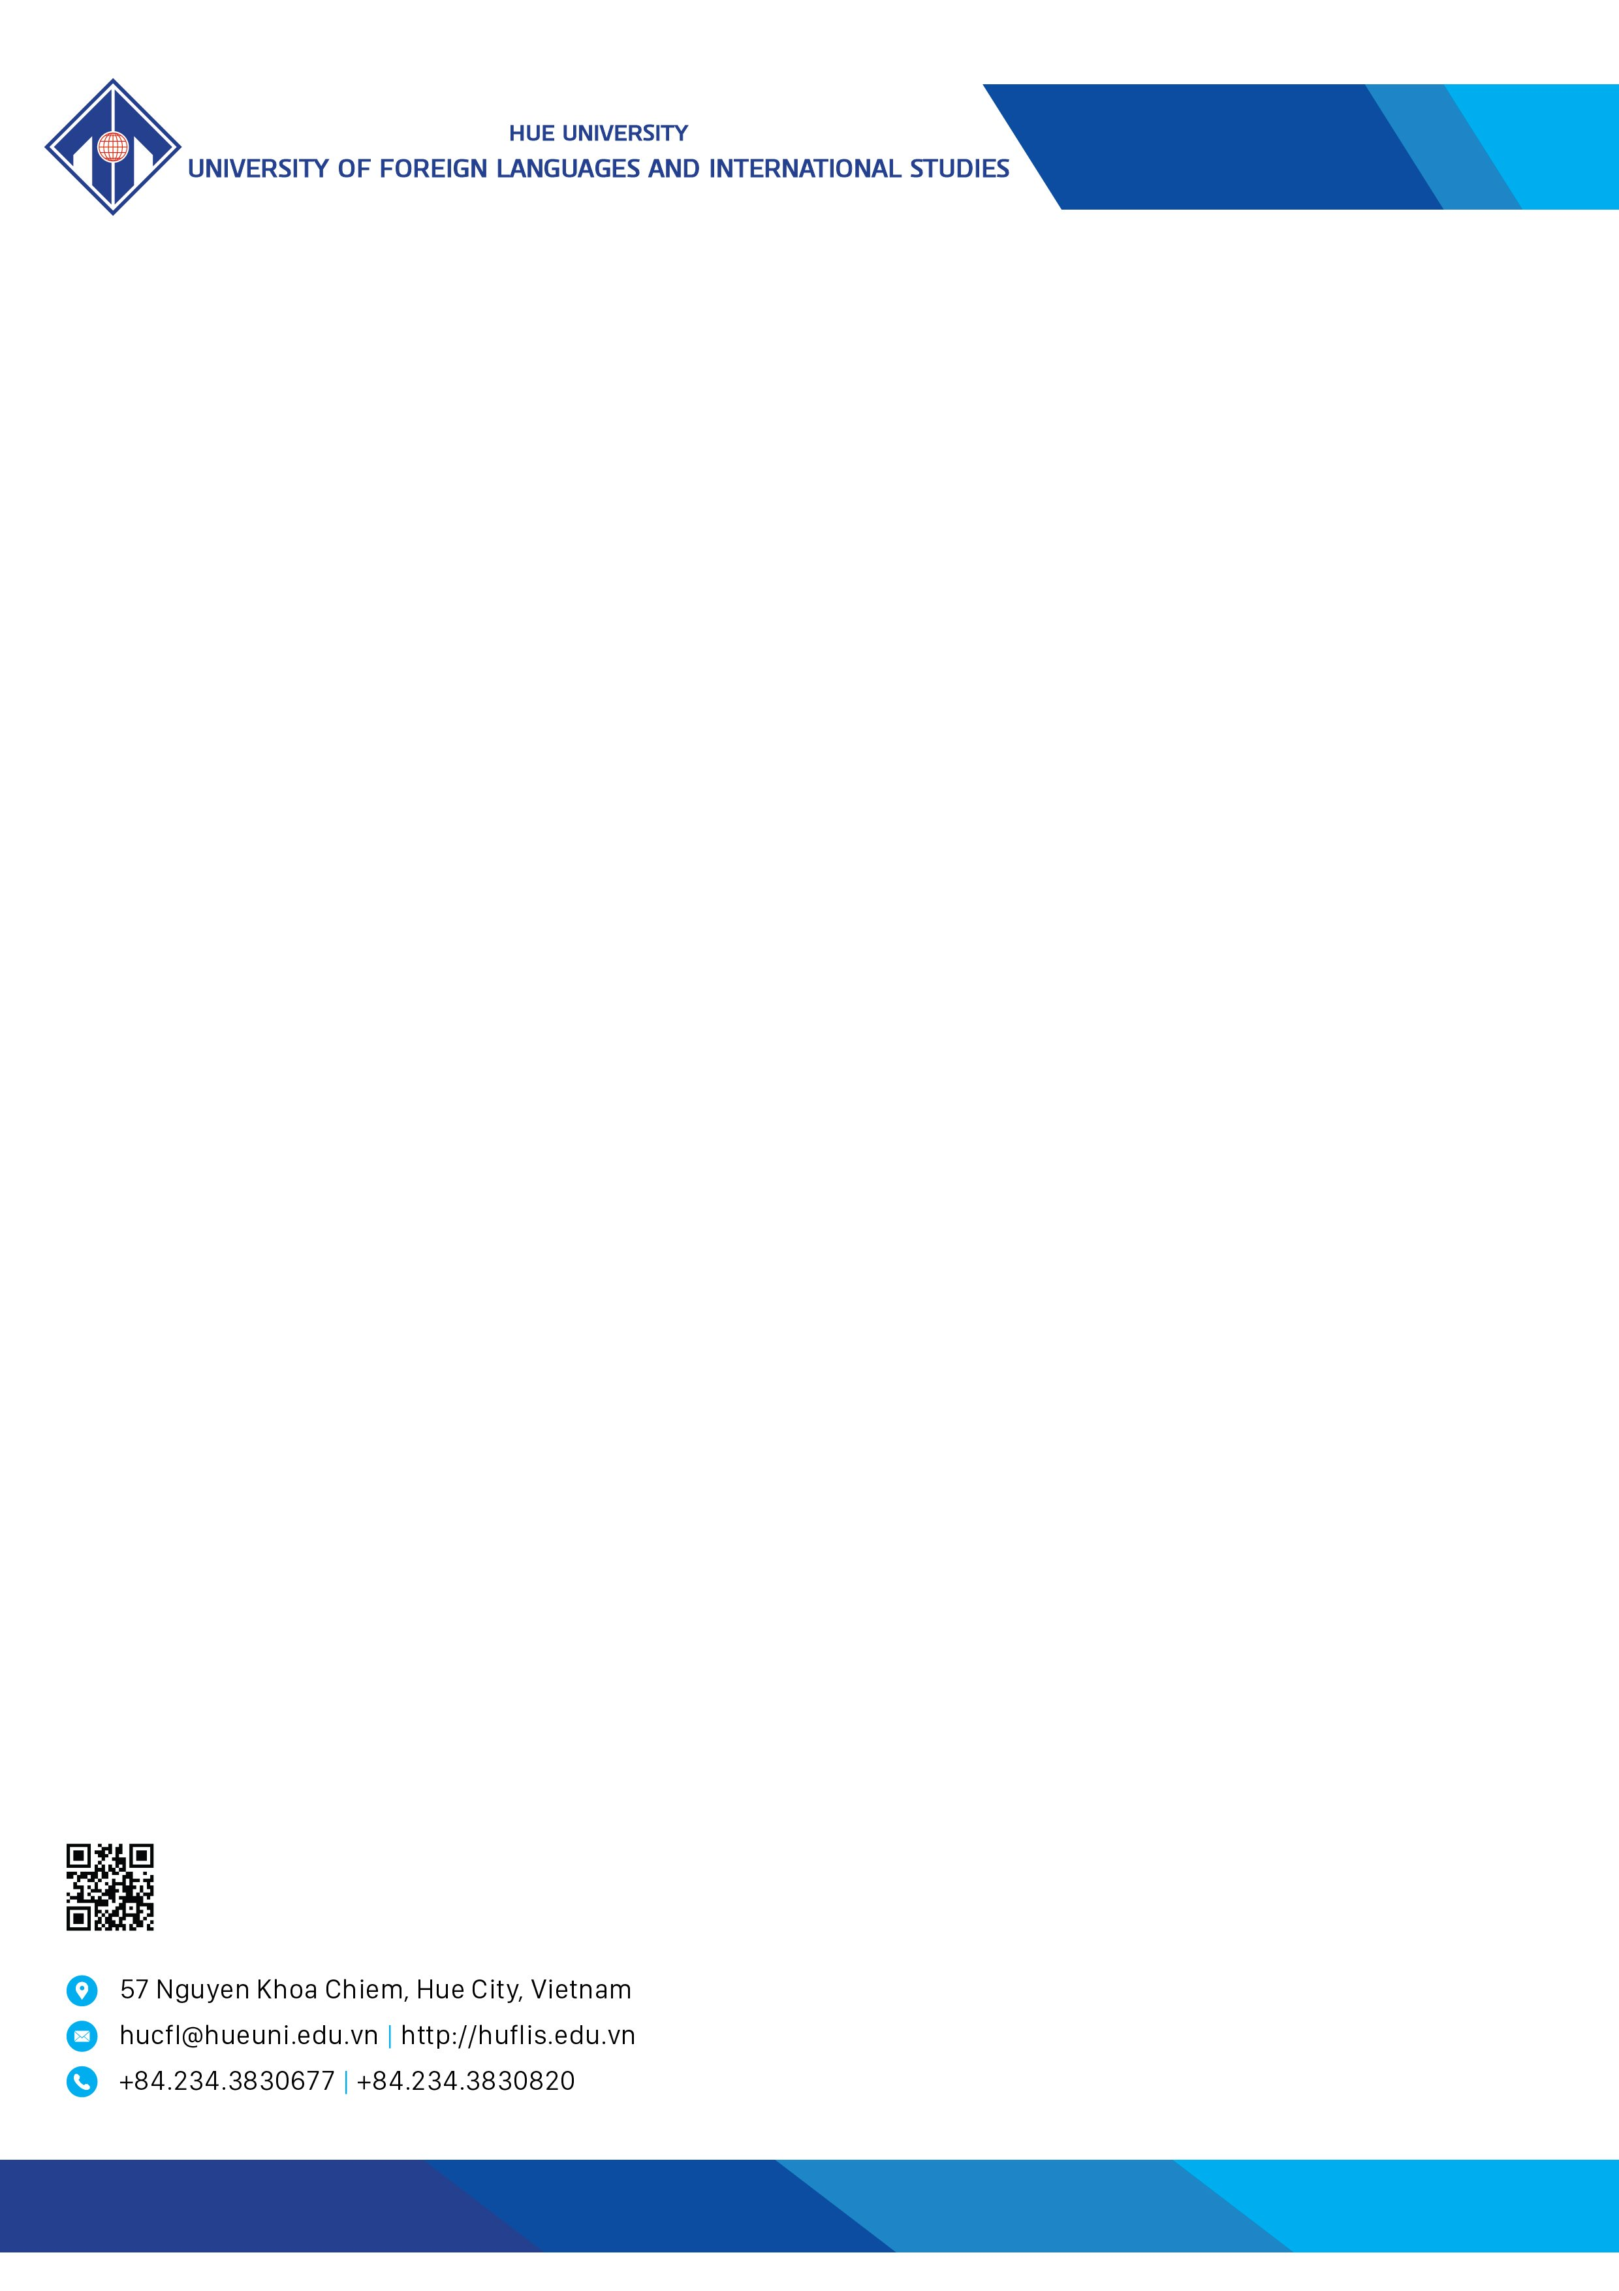

CALL FOR PAPERS

THE 11TH INTERNATIONAL CONFERENCE ON INTERDISCIPLINARY RESEARCH IN LINGUISTICS AND LANGUAGE EDUCATION, 2025
1. About the Conference
The Conference on Interdisciplinary Research in Linguistics and Language Education is a prestigious annual academic activity organized by the University of Foreign Languages and International Studies, Hue University, in conjunction with its domestic and international partners.
The 11th Conference this year is a specialized gathering that brings together linguists, language researchers, educators and enthusiasts. The event gives room for them to exchange research results and discuss future trends and directions in research in linguistics and language education.
2. Call for papers
- Conference Theme: Global Trends and Innovations in Language Teaching, Learning, and Research.
- Relevant abstracts and manuscripts of original research that have not been published or submitted elsewhere are welcomed. Abstracts and manuscripts are written in either English or Vietnamese in accordance with, but not limited to, the following topics:
- Theoretical Linguistics and Applied Linguistics;
- Translation and Interpreting Studies and Training;
- Methods, Techniques and Intercultural Issues in Language Education;
- Current Trends in Language Education Research;
- Professional Development and Critical Thinking in Language Education;
- Language Assessment and Material Development in Language Education;
- Technology and Artificial Intelligence in Language Education;
- Content and Language Integrated Learning (CLIL) in the Digital Era;
- English For Specific Purposes (ESP): Teaching, Material Development And Assessment;
- Media and Information Literacy/Digital Competence in Language Education;
- Teaching and Learning Vietnamese as a Foreign Language;
- Issues in Teaching and Learning Languages in K-12 Curriculum.

3. Conference proceedings
Research papers presented at the conference with good review results will be published either in the ISBN proceedings of the conference or in the Journal of Inquiry into Languages and Cultures by University of Foreign Languages and International Studies, Hue University. Note: Review Papers are not accepted to publish in both Conference proceedings and the Journal.
4. Important Dates
- Abstract submission deadline: August 15, 2025. Please use the following form to submit your abstract: https://forms.gle/NfHYvMU2Yv2AAFmV7 (See the attached guidelines for writing the abstract and full paper).
- Registration deadline: September 27, 2025. Register at: https://forms.gle/XXu5uPkSq7qGBvHW8
- Full manuscript submission deadline: October 27, 2025. Please use the following form to submit your full paper: https://forms.gle/1YRxxyAH35vyiyhT8 (See the attached guidelines for writing the abstract and full paper).
5. Conference Fee
- Paper review fee: 40 USD (to be transferred to university bank account given below)
- Participation fee (including refreshment, lunch, and conference materials): 20 USD (to be transferred to university bank account)
- Bank account:
- Account Holder's Name: Trường Đại học Ngoại ngữ
- Bank Account Number:122000014732
- Bank Name & Address: Vietnam Joint Stock Commercial Bank for Industry and Trade – Branch (Vietinbank Hue Branch)
- Bank SWIFT Code: ICBVVNVX460
- Structure of the transaction: Fullname_ReviewFeeLN11
or: Fullname_AttendanceFeeLN11
Bank transfers are processed during business hours: 8:00 AM–10:30 AM and 2:00 PM–4:30 PM. Transfers will not be processed on Saturdays or Sundays.
Participants are responsible for their own travel, accommodation, and other related expenses.

6. Language at the conference: English and Vietnamese
7. Contact
Office of Research Management and International Cooperation
Email: dhnn_hoithao@hueuni.edu.vn
Phone number of 0234.3.830.722.
Hue, April 10, 2025
RECTOR

PHAM THI HONG NHUNG

