Title

(The title of the article is no more than 15 words in English)

**Author name1🖂; Author name2**

**1Department, University, City, Country; 2Department, University, City, Country**

**🖂** E-mail for the corresponding author

**Abstract (120-150 words):**

Provide a self-contained and readable abstract (of up to 150 words) that briefly explains the salient aspects of the content, including, but not exclusively, the methods used to address the research question/hypothesis, a summary of the results, conclusions, applications or implications.

*Key words (3-5 key words):*

# 1. Heading 1 [use this style for level one headings]

[Type your text here]

## 1.1 Heading 2 [use this style for level two headings]

[Type your text here]

### **1.1.1 Heading 3 [use this style for level three headings]**

[Type your text here]

*Heading level 4. [Use this style for level four headings].* Run the text on after a punctuation mark.

It is best if authors use three-level headings.

***Block quote***

If the quotation is over 40 words, you need to make it a block separate from the main text. In this case, use this style to display your quote.

***Tables and figures***

If you present your data in a table, follow this sample:

Table 1

*Name of the Table*

|  |  |  |
| --- | --- | --- |
| **Items** | **Content 1** | **Content 2** |
|  |  |  |
|  |  |  |
|  |  |  |
|  |  |  |

The caption comes above the table, started with Table 1 in bold, font size 11, the table title (no more than 15 words) is in italics, font size 11, and the content in the table is in font size 10.

If you present your data in a figure, the figure must be saved as a .jpg or .png file before being inserted to the main text. The caption comes below the figure, started with Figure/Chart 1 in bold, font size 11, with the figure/chart title (no more than 15 words) in italics, font size 11.

Figure 1

*The Bloom's Taxonomy*

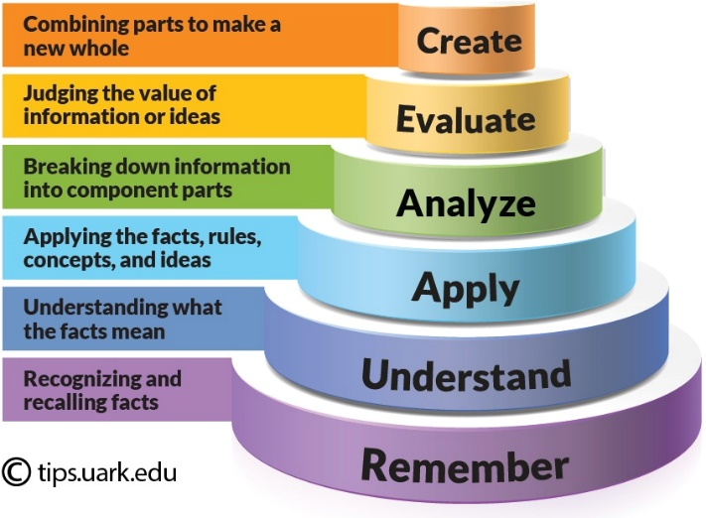

If the table or the figure is taken from a source, reference the author (after the caption) or acknowledge the source (by adding the information about it).

Please ensure that all tables are included in the main article document in an editable format (such as Word) rather than as images.

# References

Manuscripts must conform to the American Psychological Association (APA) style guidelines, 7th Edition.

Authors may refer to the *Author Guidelines* available on the website of the *Journal of Inquiry into Languages and Cultures*, University of Foreign Languages and International Studies, Hue University: [https://jilc.vn](https://jilc.vn/)

**Information about the article in Vietnamese[1]**: Provide a Vietnamese version of the title and the abstract of your article here.

TiÊU ĐỀ

**Tóm tắt (120-150 từ):**

*Từ khóa (3-5 từ):*

1. If you are an international author and have difficulty in translating the abstract into Vietnamese, leave a blank. The editorial staff will help with this if the article is accepted for publication.